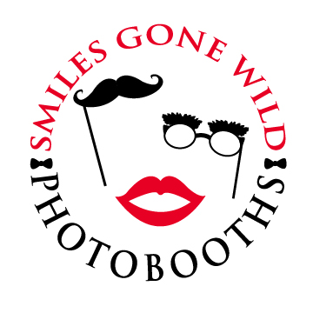

Event Information

/

Traditional Two - 2x6 photo strips (Included in Price)

OR

Postcard One - 4x6 print (For Additional Fee)

two lines (each line with 30-35 max. characters)

Arial Rounded Brush Script Helvetica

Optima Sloop Script Times

Or your custom choice

red, orange, yellow, green, blue, purple, pink, brown, black

Date of Event:

Time Event Begins/Ends:

Venue:

Venue Address:

Venue Phone Number:

Guest of Honor Name(s):

Number of Guests:

Preferred Photo Booth  
 Start / End Time:

Please choose:

Custom Footer Information:

Font choice:

Color choice: